Seismic Analysis Guidelines For The CTA Telescopes.
Written by Simon Blake, CTA Project Office 01/11/2011 Rev 1.0

Contents

1 Introduction Page 1
1.1 General Introduction Page 1
2 Sources of Seismic Data Page 2-3
3 Design Standards. Page 3
4 Seismic Analysis Methods Page 4
4.1 Equivalent Static method Page 4
4.2 Dynamic Analysis - Response Spectra Page 4-5
4.3 Dynamic Analysis - Time History Page 6
5 Foundation & Soil Structure Interaction Page 7-8
6 Modelling & Analysis Methods For CTA Page 8-12
7 References Page 13
8 Appendix 1 Page 14-16

1 Introduction

1.1 General Introduction

The CTA Site working group have identified a number of possible sites for the location of the CTA telescopes. Some of the site candidates are seismically quiet (Namibia) whilst others may be seismically active (Argentina). The resistance of the telescope structures and foundation to seismic damage must be evaluated so that the potential for facility damage due to under design or the incurring of additional costs due to over design are minimised.

Seismic activity (earthquakes) produce random broadband motion of the ground in three dimensions which typically can last from 10 to 30 seconds. The broadband characteristics of the ground acceleration frequency spectra tend to excite a wide range of structural frequencies that potentially could excite multiple eigenfrequencies in the telescopes which in turn may amplify structural motion at multiple modes. The exact seismic response of the telescope will be highly dependent upon the structural stiffness and damping of the telescope structure and subsystems.

This document is not intended to be a design standard, it is merely intended to provide guidance on how to apply finite element methods to the seismic analysis of the CTA telescope structures. It serves to assist those undertaking seismic analysis of the CTA telescopes to locate the relevant sources of seismic information and design standards and to then apply seismic analysis methods to the design of the telescope structures.

2 Sources of Seismic Data
In order to apply representative accelerations to the finite element structural model the analyst must first know the magnitude of the ground accelerations that the structure is likely to experience. These may be evaluated by specifying the magnitude of an operational earthquake (sometimes referred to as the operational base earthquake) and a survival earthquake (sometimes referred to as the maximum likely earthquake). The operational earthquake is herein defined as the maximum earthquake level that the telescope must withstand without suffering damage that would prevent quickly resuming normal operation. The survival earthquake is defined herein as the maximum earthquake level that the telescope will withstand without suffering such severe damage that it proves uneconomic to resume use of the telescope. The operational and survival earthquakes are defined via the magnitudes of peak horizontal and vertical accelerations and are site specific.

Seismic maps indicating global peak ground acceleration magnitudes are available from GSHAP (Global Seismic Hazard Assessment Programme). An example of the GSHAP map of ground acceleration is shown as Figure 1.



Figure 1 GSHAP map of peak ground acceleration

Using the GSHAP map of peak ground acceleration the seismic magnitudes may be estimated for the candidate sites for CTA. For the HESS site (Namibia) the peak ground accelerations are found to range from 0.40 to 0.80 m/s² (classed as low hazard) and for the Argentina sites (El Leoncito and San Antonio de los Cobres) the peak ground accelerations are found to range from 4.0 to 4.8 m/s² (classed as high hazard).

More detailed views of the GSHAP hazard map showing the ground acceleration amplitudes for the South America and African regions are shown in Appendix 1 as Figures A1 and A2 respectively.

3 Design Standards.
Established and commonly used international standards for seismic qualification exist, i.e. Uniform Building Code Chapter 16, ASCE 7 and Eurocode 8. Within Europe general rules for the design of structures for seismic activity are given in Eurocode 8 (design of structures for earthquake resistance), it is therefore suggested that for initial generic seismic analysis of the CTA telescopes that the procedures presented in Eurocode 8 be adopted. This will permit seismic analysis to be undertaken prior to the site selection, site specific seismic data and soil conditions can then applied once the candidate sites are known.

Before applying seismic design codes the analyst must consider whether the telescope systems under consideration are safety critical or non safety critical. When designing for safety critical systems it is common practice to adopt a design approach assuming that damage to the safety critical aspects of the structure is avoided completely (linear elastic methods are used). For non safety critical systems it is common to assume that the structure should survive the earthquake event but that some local damage may result (non linear elastic-plastic methods may be used wherein some degree of plastic deformation may be permitted in order to increase failure limits).
4 Seismic Analysis Methods
A number of methods for undertaking seismic analysis exist. If the structure can be considered to have a linear response then for static analysis the equivalent static method may be used, for dynamic analysis the response spectrum method may be used. If the structural response is non linear then direct integration time history methods may be used. A brief overview of these is given below.
4.1 Equivalent Static Method

The equivalent static method is the simplest way to conduct an assessment of the structure to withstand seismic loads. The horizontal acceleration amplitudes are applied as a static body force (allowing for structural resonance due primarily to the first mode) to the structure. The equivalent static method is useful as a quick design check to verify whether a structure would be able to withstand the effects of seismic accelerations. However due to the high probability of multiple interacting and closely coupled modes it is necessary to consider the dynamic behaviour of the structure by analysis in the frequency or time domain.

Therefore whilst the equivalent static method will permit initial assessment of the ability of the telescope structure to withstand earthquake loads as a minimum design requirement the seismic design should utilise dynamic analysis in the frequency or time domain using site specific response spectra or acceleration time histories. General rules for the design of structures for seismic activity are given in Eurocode 8 (design of structures for earthquake resistance).

4.2 Dynamic Analysis - Response Spectra

A response spectrum is generated from time history records of seismic activity. The time history data is used to produce a spectrum of seismic action (usually acceleration) vs. natural frequency allowing the ground motion to be expressed as the response of a single degree of freedom system having a prescribed period and damping ratio.

Knowing the response spectrum, and assuming that the structural response can be decomposed into discrete modes the structural response at a single mode may be estimated. The overall structural response can then be estimated by combination of the individual modal responses using modal superposition.

An example of a response spectrum for the well known El Centro earthquake of 1940 is shown below in Figure 2.

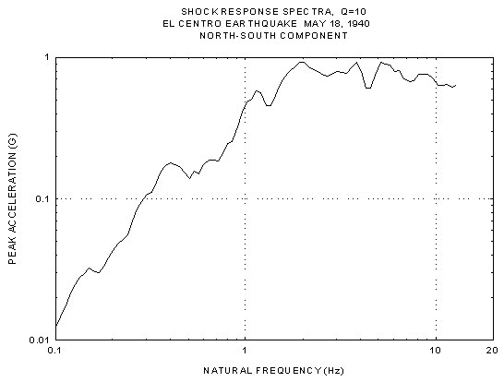

Figure 2 Seismic acceleration frequency response spectrum for El Centro earthquake.

However such a response spectrum is specific to a particular seismic event and soil condition. For design purposes it is usual to adopt a smoothed spectrum derived from response spectra from several seismic events obtained at or near to the site of interest. However where these are not available it is possible to use a normalised design response spectrum obtained from the seismic codes (usually defined for a reference site classification such as rock) and then scale this using a site classification factor (soil coefficient) that defines the ratio of spectral accelerations on the target site to those in the reference spectrum. However it must be emphasised that for deep soft soil sites or sites close to active fault zones site specific spectra should be used. The interpretation of time history records and production of the site specific response spectra are non trivial and are best undertaken by a seismologist.

An example of a design response spectrum is shown below in Figure 3.

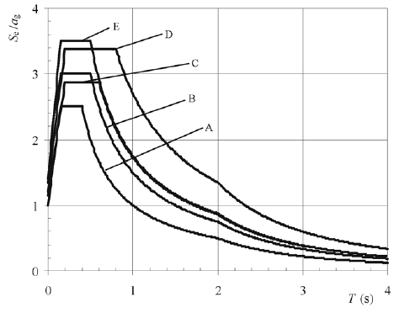
Figure 3 Seismic design response spectrum example for soil types A to E
(taken from Eurocode 8).

4.3 Dynamic Analysis - Time History
Time histories of the ground acceleration recorded during a seismic event (termed accelerograms) provide data for the acceleration amplitude vs. time. An example of a time history record (accelerogram) for the 1940 El Centro earthquake is shown below as Figure 4.

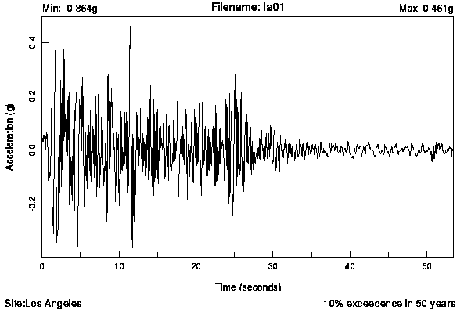
Figure 4 Ground acceleration time history for El Centro earthquake

Due to the random nature of earthquakes it is common practice to generate a synthesised time history from several accelerograms obtained for the target site. Furthermore since the direction of ground motion may not be known beforehand it is necessary to apply time history data to all three orthogonal axes and then ensure that the axes of excitation are aligned with the major and minor axes of lateral stiffness of the structure. It is emphasised that wherever possible ground acceleration data obtained from actual earthquakes recorded at or near to the candidate site should be used for the time history.

5 Foundation & Soil Structure Interaction
The compliance of the underlying soil can dramatically affect the response of the structure to earthquake loads and may result in amplification or attenuation of ground motion in addition to changing the eigenfrequencies and eigenmodes of the structure. A number of analysis methods for representing the soil stiffness and damping are discussed below.
5.1 Fixed Base Model.
If the structure is built directly on solid rock then the ground base motion will be transmitted directly to the structure. In this instance soil-structure interaction can be ignored and the ground motion applied directly to the base of the structure.
5.2 Equivalent Spring Method.
If the structure is built onto soil a linear spring or spring-damper (dashpot) representing the soil stiffness and damping characteristics may be attached to the base of the structure. Vertical springs or dashpots may be used however since there will be simultaneous horizontal and vertical accelerations arising from the ground motion it will be necessary to model both the vertical and horizontal (rocking) and torsional stiffnesses. This is particularly the case for structures having a flexible base or those expected to experience significant differential displacements. If the structure can be considered to have a rigid base then it is more computationally efficient to tie all the nodes in the finite element model of the base to a single node using constraint equations and then apply springs or dashpots in the three orthogonal axes corresponding to the ground motion.
A method for calculating estimated values of the magnitude of the stiffness and damping to be assigned to the spring and dashpot entities for vertical, rocking and torsional motion is given in ASCE 4-98 (Seismic Analysis of Safety Related Nuclear Structures), this takes into account the shear stiffness, Poisson’s ratio and density of the soil and may be applied to both rectangular and circular based structures.
5.3 Soil Properties.
Soil exhibits plastic deformation and non linear hysteretic behaviour under loading and unloading. There are a large number of constitutive soil models that can be adopted ranging from simple first order linear spring-damper models that model elastic-plastic behaviour (Mohr-Coulomb) to more complex non linear elastic-plastic models with and without strain hardening, creep and reversible stress-strain (hysteretic) characteristics (such as the various hyper and hypoelastic soil models). Since the most widely used soil model tends to be the isotropic linear elastic-plastic model with damping (Mohr-Coulomb) this should be used as a baseline for the analysis. It is stressed however that when undertaking finite element analysis the behaviour of the soil model should ideally be verified by comparison with laboratory test data.
Assuming therefore that we initially adopt the linear elastic-plastic Mohr Coulomb soil model we need to define the shear stiffness, strength, Poisson’s ratio, density and damping coefficient for the soil type under consideration. Data curves showing the stiffness (shear modulus vs. shear strain) and damping for various soil types ranging from loose sand to clays are given in the paper by Bolton-Seed & Idris (Ref 1). In addition if the soil exhibits high permeability and water content or is susceptible to liquefaction during earthquake events (for example loose sands) this must be taken into account in the soil model.

6 Modelling & Analysis Methods For CTA
6.1 General

The seismic design codes are generally specific to buildings constructed as simple frameworks having long periods of vibration, a typical response spectrum from Eurocode 8 for example may correspond to a frequency range from 0.1 to 10 Hz. The CTA telescopes on the other hand are complex three dimensional structures that may possess eigenfrequencies of significance above 10 Hz and multiple closely coupled modes. Therefore care must be taken to adopt appropriate analysis methods.

Whilst both the equivalent static method and the response spectrum method are easy to implement their application is limited to linear elastic analyses. In the case of the CTA telescopes the complex three dimensional construction of the telescope structures and the probability of having multiple closely coupled modes mean that a non linear dynamic analysis including the effects of soil structure interaction performed in the time domain may be required.

A suggested approach for undertaking the seismic analysis of the telescopes is proposed below:

- Develop design criteria.
- Undertake equivalent static analysis.
- Undertake linear dynamic analysis using the response spectrum method.
- Undertake non linear dynamic analysis using direct time integration methods.

Each of these are described in turn below.

1 Develop design criteria

First of all the seismic design criteria must be defined for the candidate sites. The design criteria should impose a seismic “survival event” and an “operational event” for CTA. To define the survival event we should assume a seismic event having a 10 % probability of being exceeded in 50 years (this may be taken from either the GSHAP hazard map data or from time history accelerogram data specific to the candidate sites if available). All safety critical systems and structural elements should be identified and be required to remain intact although some failures of non critical elements may be permitted. Consensus must be reached within CTA to define which elements and subsystems of the telescope will be permitted to fail.

To define the operational event we should assume a seismic event having a 20 % probability of being exceeded in 50 years (again using GSHAP hazard map data or time history accelerogram data specific to the candidate sites if available). Some damage to non safety critical elements and subsystems may be permitted however full use of the telescope should be recovered after a short period of time. We must again reach consensus within CTA upon which elements and subsystems of the telescopes may be permitted to fail and how long we might allow the telescopes to be offline before they can resume normal operations.

2 Undertake Equivalent Static Analysis

Having defined the survival and operational seismic event acceleration magnitudes it will be useful to quickly determine whether a candidate telescope design will survive these events. This may be achieved by applying the ground horizontal and vertical accelerations directly to the structure as a static body (inertia) load.

Two load cases should be specified for the equivalent static method analysis, these could be defined as for example a survival event having a peak ground acceleration 0.34G (10% probability of exceedance in 50 years) and an operational event having a peak ground acceleration of 0.2G (20 % probability of exceedance in 50 years). Note that these accelerations magnitudes are given as examples only and that actual peak ground acceleration magnitudes should be chosen for the specific candidate site. In both cases it is suggested that the acceleration magnitudes are multiplied by a factor of 3.0, this accounts for amplification effects due to the structural response at the first mode. If data for the vertical acceleration component are not available then the vertical acceleration in both cases should be assumed to be equal to 0.67 times the horizontal acceleration magnitude with both the horizontal and vertical accelerations being applied simultaneously.

Since the design of the CTA telescopes will employ finite element methods it is proposed that a refinement to the equivalent static analysis could be employed. The equivalent static method described above assumes that the structural response is dominated by the first mode and that entire mass of the structure participates in the first mode. In practice only a fraction (perhaps 70-80 %) of the structural mass will participate in the first mode, therefore the equivalent static method will tend to overestimate deflections. If a modal analysis has been undertaken and data for the eigenfrequency and effective mass participation is available for each mode the products of the spectral acceleration and the effective mass may be summed for each mode to obtain the effective shear for each mode. The sum of the effective shears for each mode may then be divided by the total effective mass (from the modal analysis) to obtain the equivalent static acceleration for each mode which can then be applied to the structure.

3 Undertake Linear Dynamic Analysis (Response Spectrum Method)

If the equivalent static method analysis indicates that the telescope structure is likely to survive the equivalent static forces due to the seismic events then the dynamic response of the telescope structure to seismic loads should be evaluated. Since the response spectrum method is less computationally intensive than a fully non linear direct time integration analysis then the response spectrum method should be applied first.

For the response spectrum analysis a response spectrum should be chosen based upon a site specific seismic event that has a 10% probability of being exceeded in 50 years. If these are not available then a normalised response spectrum defined in the seismic design codes (e.g. Eurocode 8) could be used with appropriate correction for soil classification for the candidate site. A modal analysis of the telescope structure should then be undertaken ensuring that at least 90 % of the translational and torsional structural masses are included in the analysis. If significant structural masses exist that do not contribute to the structural stiffness they may be coupled to the structure using constraint equations or link elements having the appropriate stiffness and degrees of freedom.

Having identified the eigenfrequencies of each significant participating mode the acceleration response may be determined from the response spectrum design curve. Note that the response spectra are often shown assuming 5% damping and that the values representative of the telescope structure may be less (2-3%), therefore the acceleration response must be scaled upward for the appropriate level of modal damping. The modal responses may then be combined to give an estimate of the overall structural response. Care must be taken when performing the modal combination, a straightforward summation of absolute values (such as in the commonly used square root sum of squares method) is very easy to implement but is generally valid only for linear structures having widely separated modes. In the case of the CTA telescopes (especially the LST) where closely coupled modes may exist and directions of the eigenvectors may not be coincident with the direction of excitation it is suggested that the complete quadratic combination (CQC) method for summating the modal responses is used since this also considers the signs of the modal contributions.

4 Undertake Non Linear Dynamic Analysis (Direct Time Integration Method)

Application of the time dependent ground motions (acceleration time history) onto the telescope structure will provide the most accurate simulation of the structural response to seismic events but a full direct integration time history analysis will be computationally intensive. The advantage of performing the direct integration time history analysis is that both non linear and dynamic structural effects can be simulated.

The question as to whether or not to use direct time integration methods may be considered by considering the potential for closely coupled modes to exist in the telescope structures. In general terms if the mass of a subsystem (for instance the camera) is less than 4% of the main structure to which it is attached then coupled modes are most likely not present and the output accelerations of the main structure may be used as the input motions for the subsystem. If the mass of the subsystem exceeds 4% of the main structure mass then it is likely that the eigenfrequencies will be closely spaced and that coupled modes will exist. In these circumstances a fully coupled analysis of the main and subsystem structures (incorporating the mass and stiffnesses of the subsystem structure) must be undertaken.

If the telescope structures can be considered to behave linearly (as perhaps in the case of the SST SC option with its short focal length and lightweight camera) it may be possible to reduce computational analysis requirements by first of all undertaking a mode based time history analysis. This is a modal superposition method similar to the response spectrum method wherein the modes are first calculated and then the acceleration time history is applied as an input to the structure. The advantage is that since the modal response is already known the structural response to a large number of seismic loading scenarios can be quickly evaluated far more rapidly than they could be via a complete direct integration time history analysis. However it is probable that the DC option telescopes (SST, MST and LST) will probably exhibit some non linearity due to the effects of the large camera mass and light damping of the mast structure resulting in mode coupling. In this event the direct integration time history analysis method is the preferred analysis method for the CTA telescopes if computational overheads permit its use. It will provide detailed information of the dynamic and non linear local and global responses for all of the telescope system elements including structural response, foundation compliance and soil-structure interaction. If seismic isolators or dampers are used to isolate the telescope from ground motion during a seismic event (as is probable for the LST) then the system is certain to exhibit non linear behaviour and direct integration time history analysis remains the only analysis method that may be used.

Analysis Deliverables

The objective of the analyses should be to determine the resistance of the telescope structures to seismic loads and to quantify interface and body loads imposed onto the telescope subsystems. It is suggested that some of the desired outputs of the seismic analysis should be :

- Identification of the telescope structure global response.

- Identification of areas of high stress/strain (as a general rule for ferrous materials strains should be less than 5% in order to avoid permanent (plastic) deformation.

- Reaction forces at base/foundation (uplift & overturning moment with maximum wind load and seismic load condition).

- Interface loads to : Mirrors.
Drive systems (bearings, gearboxes, drive tracks/rails, brakes.
Camera.

- Seismic accelerations & forces for subsystems (camera, electronics, mirrors, drive systems)

- Evaluate the fragility of sub systems to survival and operational seismic loads and where necessary either define need for seismic isolators/restraints or calculate seismic loads that will be imposed upon sub systems and impose these upon the design specification for these subsystems.

- Assess need for seismic isolators (elastomeric supports, shear pins) between telescope and ground, or between telescope structure and critical sub systems.

Simon Blake
CTA Project Office
01/11/2011.

References

1] “Soil Moduli And Damping Factors For Dynamic Response Analysis”, H. Bolton Seed and I.M. Idris, Report EERC 70-10, Earthquake Engineering Research Centre, University of California Berkeley.

Appendix 1

GSHAP (Global Seismic Hazard Assessment Programme) Maps Showing The Peak Ground Acceleration Magnitudes For South America And Africa.

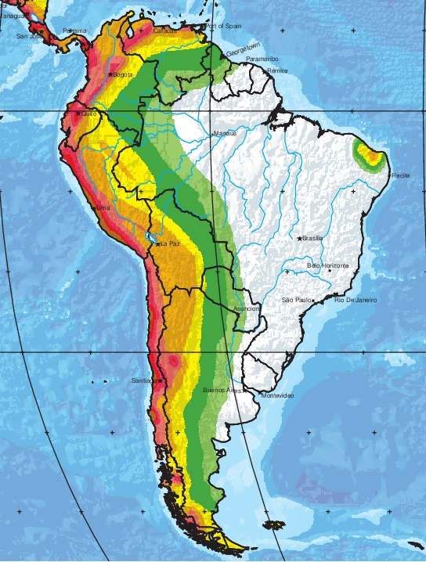
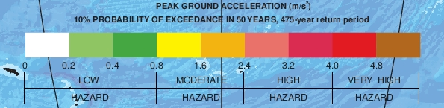

Figure A1. GSHAP Hazard Map For South America.

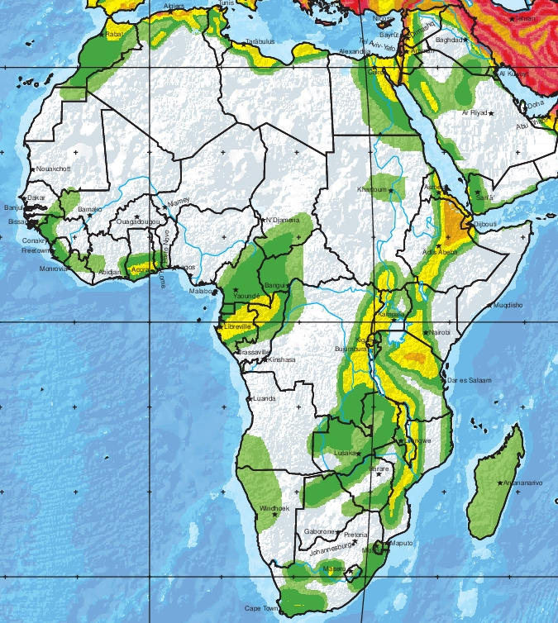

Figure A2. GSHAP Hazard Map For Africa.

